YOUR UPCOMING PROCEDURE IS SCHEDULED:

_________________________check in at______________________

With

Dr. Evans Dr. Srinivasan Dr. Tiwari

Please call 541-222-6200 with any questions.

Thank you for scheduling your colonoscopy. A colonoscopy is an exam used to look for changes — such as swollen, irritated tissues, polyps, or cancer — in the large intestine (colon) and rectum. During a colonoscopy, a long, flexible tube (colonoscope) is inserted into the rectum. A tiny video camera at the tip of the tube allows the doctor to view the inside of the entire colon. If necessary, polyps or other types of abnormal tissue can be removed and/or biopsies be taken through the scope during a colonoscopy. Tissue samples (biopsies) can be taken during a colonoscopy as well.
At PeaceHealth we are committed to disease prevention and keeping you healthy. Colon cancer is a leading cause of cancer deaths in the USA. PeaceHealth, and national experts in prevention and health, recommend screening for colorectal cancer in adults beginning at age 45 years and continuing until at least age 75 years (may be longer for some high-risk patients). Our department welcomes the opportunity to participate in your health care.
Thank you for choosing PeaceHealth for your recent health care needs. Our mission is to promote personal and community health by providing you with excellent care. Please don’t hesitate to call our office if have questions.

Table of Contents
FYIs………………………………………..……….…………..page 2
Instructions for your Colonoscopy…...…page 3-5
Special Medications…………………………………..page 6
Suprep……………………………….……………….……….page 8
NuLytely ………………………………….…………..……..page 9
SuTab……………..………………………….……………...page 10
FAQs………..…….……..…………………………….……..page 12
Directions to the Clinic……..…………..……….…page 14

CANCEL/RESCHEDULING PROCEDURE
If you must cancel or reschedule your appointment, please call 541.222.6200 to give a minimum of 1 week notice, this allows us to schedule another patient.

TRANSPORTATION

You must arrange for an adult family member or friend to drive you to your procedure and home from your procedure. They will need to be available throughout your appointment. It It is the policy of PeaceHealth that you have a responsible adult accompany you home after your procedure (a bus or taxi ride is not an option unless you are accompanied by a responsible adult.) In the event you are unable to arrange for a driver to accompany you to and from your colonoscopy, your procedure will need to be rescheduled.

SEDATION
Sedation medication helps you relax and feel comfortable during the procedure. You may feel fine after your procedure, but your judgement will be impaired from the sedation medication you receive. *Do not drive, make legal decisions, return to work, or drink alcohol for the remainder of the day.

CURRENT MEDICATIONS

All daily medications may be taken until 2 hours before your check in time. This includes blood pressure medications and beta blockers, unless instructed otherwise. A staff member will be calling to go over your blood pressure medications with you prior to your procedure. If you take Losartan and/or Lisinopril, hold that medication the day of the procedure.
CONSTIPATION
See pg. 6

BLOODING THINNING MEDICATIONS

See pg. 6 “Special Medication Instructions”
DIABETIC PATIENTS
See pg. 6 “Special Medication Instructions.”

PRESCRIPTION PREP PICKUP

Please follow the instruction in this packet and not the instructions provided when you pick up the prescription. A member of our staff will call you approximately one week prior to your procedure date to confirm procedure time, pharmacy preference for your colon prep prescription to be sent and answer any questions you might have. Our office MUST make contact with you to confirm, or your procedure will be canceled, if you do not receive a call from our staff a week prior to your procedure or have questions, please call 541-222-6200. If you prefer one of the bowel preps over the other, please let our staff know when you are called for procedure confirmation. Contact your insurance regarding coverage for different prep medications if needed.
INSTRUCTIONS FOR YOUR COLONOSCOPY
All bowel preparations work the best when you take them as a split dose. You will take the first dose the evening before your colonoscopy. The second dose you will take the day of your procedure. Your preparation for your colonoscopy is a crucial part to a successful procedure. It is extremely important to drink all of the colon cleansing solution.
GLP - 1 Class | Brand Name
Exenatide | Byetta
Exenatide | Bydureon
Liraglutide | Victoza
Albiglutide | Tanzeum
Dulaglutide | Trulicity
Lixisenatide | Lixumia
Lixisenatide | Adlyxin
Semaglutide | Ozempic
Semaglutide | Rybelsus Wegovy
PEG-loxenatide | Fu Laimei
Uraglutide | Saxenda
Tirzepatide | Mounjaro

SEVEN DAYS PRIOR TO COLONOSCOPY
If you are prescribed a GLP-1 medication such as listed in the table on the right, you will need to stop taking it 7 days prior to procedure.

FIVE DAYS PRIOR TO COLONOSCOPY:
- Avoid nuts, seeds, beans, corn, dried fruits, raw vegetables, salad, popcorn, and multi grain breads.
- Stop taking Fish Oil/Omega-3 supplements and oral Iron supplements.
- Low fiber/residue diet (see last page)

ONE DAY BEFORE COLONOSCOPY:
- MORNING: Clear liquids only today. No solid food, milk products or alcohol permitted. Hold Metformin

Clear liquids you may have include (nothing red or purple):

Gatorade Crystal Light Clear Fruit Juice (apple or white grape juice)
Carbonated beverages Popsicles Jell-O or Gelatins
Black Coffee (sugar is ok) Black Tea (sugar is ok) Vitamin water
Tea

- 5:00 PM: Begin to drink the first dose of your prescription preparation.
- No chewing tobacco or gum after midnight.
ON THE DAY OF COLONOSCOPY

- Hold Metformin
- 5 hours prior to your check-in, drink the remainder of the preparation - one 8 oz. glass every 15 minutes until gone. Finish all prep 2 hours prior to check in.
- Continue drinking clear liquids (except broth) until 2 hours prior to your check-in.
- 2 hours prior to your check-in, Nothing by mouth (not even water) until after procedure.
- Dress in comfortable clothes that can be taken off and put on easily.
- Bring or wear socks.

TIPS TO TOLERATE YOUR PREP
- Use Vaseline/A&D ointment or baby wipes for anal discomfort.
- After you mix your prep solution, chill it in the refrigerator for a few hours before drinking it (drink within 24 hours of mixing).
- To decrease the bad taste, try drinking quickly. Between sips of prep, you can use pieces of lemon lime, mints or menthol drops or candies by mouth.
- If you start to feel bloated or nauseous, slow down your fluid intake, try walking around and get some fresh air. This should improve as you start to have frequent bowel movements.
- Drink through a straw
- Use of personal hygiene cleansing wipes may be more soothing than toilet paper.
- Brushing your teeth or use of mouthwash may help to moisturize mouth.

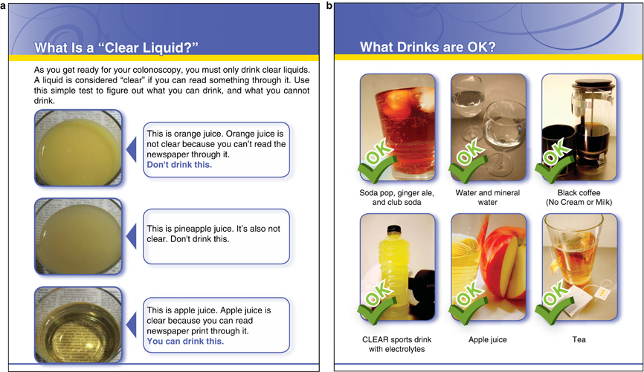
Information from The Department of Medicine, VA Greater Los Angeles Healthcare System, Los Angeles, California 90073, USA. bspiegel@mednet.ucla.edu

IS YOUR PREP WORKING?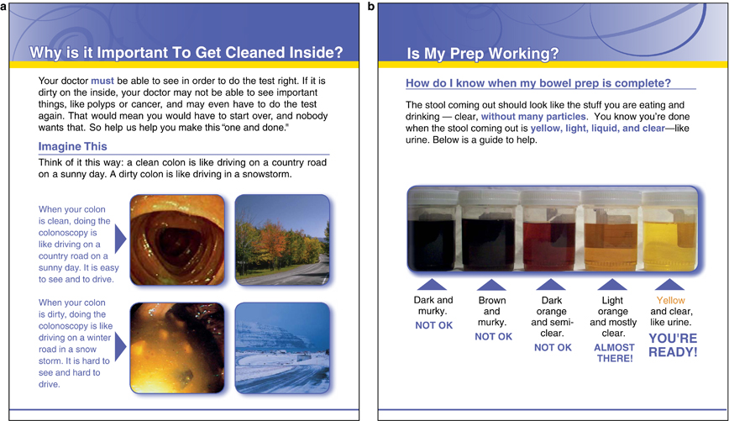
Information from The Department of Medicine, VA Greater Los Angeles Healthcare System, Los Angeles, California 90073, USA. bspiegel@mednet.ucla.edu
SPECIAL MEDICATION INSTRUCTIONS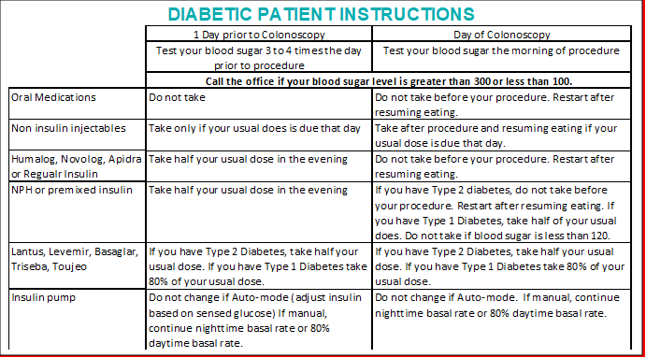
PATIENTS SUFFERING FROM CONSTIPATION
If you suffer from constipation, have hard bowel movements or have been on pain medications please let the staff member know when they call to confirm your appointment time. To increase the success of the prep you will need to take extra medications.
(Available over the counter at your pharmacy, must be purchased in advance)
5 DAYS BEFORE COLONOSCOPY
- Take 17 grams of MiraLAX twice a day or as directed by staff.

1 DAY BEFORE COLONOSCOPY
- Take bowel prep as directed.
- If you do not have a bowel movement within 2 hours of starting prep, take 20 mg (4 tablets of Dulcolax/Bisacodyl)
**If you suffer from chronic constipation, 2 days of clear liquids would be helpful**

DIABETIC PATIENT INSTRUCTIONS
- If you take a GLP-1 “tide” injectable diabetic medication (Trulicity, Byvetta, Victoza) DO NOT take for 1 week prior to your procedure.
- If you take a “gliflozin” diabetes pill (Farxiga, Invokana, Jardiance), DO NOT take for 3 days prior to your procedure.
- Take ½ your usual does of intermediate-acting insulin (NPH or premixed) the night before and NONE the morning of your procedure.
- Take ¾ your usual does of long-acting insulin (Lantus) when you normally take it (evening or morning) the day before and NONE the morning of your procedure.
- DO NOT take any oral diabetic medications the day prior to your procedure. DO NOT take any oral or injectable diabetic medications on the morning of your procedure.
- If you have a manual insulin pump, keep it on nighttime basal the morning of your procedure. Automatic pumps can be left on sensing mode.
- If you take Metformin, you must:
- Hold on prep day and day of procedure for a colonoscopy
- Hold on day of procedure only for EGDs

PATIENTS ON BLOOD THINNING MEDICATIONS
If you take any medications to thin the blood such as Coumadin, Warfarin, Plavix, Eliquis, Pradaxa, Effient, Jantovan, Pletal, or Xarelto, you will need specific instructions when to stop these medications. Most patients will need to stop these medication 3 or more days prior to your procedure.
A staff member will be calling to confirm your appointment and will go over your special instructions.

SUPREP, SUFLAV BOWEL PREPARATION INSTRUCTIONS

Please Be Aware: The instructions on the SuPrep box may be different from the instructions in this pamphlet.
Read and follow the instructions provided below

Suprep comes with two 6-ounce bottles of solution and a 16-ounce mixing container.
THE DAY BEFORE COLONOSCOPY
Start clear liquid diet in the morning.
THE NIGHT BEFORE COLONOSCOPY
*Start at 5:00PM
- Pour one 6-ounce bottle of solution into mixing container.
- Add cold water to the 16-ounce line on the container and mix well. Do not drink Suprep without adding water.
- Drink all the mixed solution in the container.
- Over the next hour, drink two 16-ounce containers of water. This is a very important step. This fluid allows the bowel prep to cleanse your colon better and helps you stay hydrated.

DAY OF COLONOSCOPY
*Start at least 5 hours prior to your check in time.
- Pour the second 6-ounce bottle of solution into mixing container.
- Add cold water to the 16-ounce line on the container and mix well.
- Do not drink Suprep without adding water.
- Drink all the mixed solution in the container.
- Over the next hour, drink two 16-ounce containers of water. This is a very important step of your preparing for your procedure. This fluid allows the bowel prep to cleanse your colon better and helps you stay hydrated.

TWO HOURS BEFORE CHECK IN
- Stop drinking all clear liquids.

REMINDER
NOTHING BY MOUTH 2 HOURS BEFORE CHECK IN
Otherwise, your procedure will be rescheduled

NuLytely, GaviLyte-C, PEG-3350, OR GoLYTELY BOWEL PREPARATION
Please Be Aware: The instructions included with prescription may be different from the instructions in this pamphlet.
Read and follow the instructions provided below
HOW TO PREPARE THE BOWEL PREP SOLUTION
- Fill the container halfway with lukewarm water. Warm water helps the powder dissolves the powder better than with cold water.
- Shake the container vigorously to dissolve the powder.
- Add enough cold water to the fill line marked on the container. Shake the jug vigorously a second time. The full container holds sixteen 8-ounce cups of solution.
- Do not add ice or any flavorings to the solution.
- The container must be stored away from direct light or heat.
- You can store the container in the refrigerator or on ice until you drink all of the preparation.
- Drink all the solution within 24 hours after mixing it.
THE DAY BEFORE COLONOSCOPY
Start clear liquid diet in the morning.
THE NIGHT BEFORE COLONOSCOPY
* Start at 5:00pm
- Shake the container of bowel cleansing solution well.
- Drink one 8-ounce glass of the solution quickly. The bowel cleansing solution does not work as well if you drink small amounts (sips).
- Drink one cup of the solution every 10 to 15 minutes, until you drink 12 cups of the preparation. This will take approximately three hours.
- Keep the remaining 4 cups of solution to drink the day of your colonoscopy. You may keep it on ice or refrigerate the preparation.
DAY OF COLONOSCOPY
*Start at least 5 hours prior to your check in time.
- Mix the solution by shaking the container vigorously.
- Quickly drink one 8-ounce cup of bowel prep solution.
- Every 10 to 15 minutes, drink another cup of bowel prep solution, until you drink all of the solution, or when your bowel movements are clear and do not have solid material.

TWO HOURS BEFORE CHECK IN
- Stop drinking all clear liquids.

REMINDER
NOTHING BY MOUTH 2 HOURS BEFORE CHECK IN
Otherwise, your procedure will be rescheduled

SuTab BOWEL PREPARATION INSTRUCTIONS
Please Be Aware: The instructions on the SuTab box may be different from the instructions in this pamphlet. Read and follow the instructions provided below
SuTab comes with two bottles of 12 tablets each and one 16-ounce cup

THE DAY BEFORE COLONOSCOPY
Start clear liquid diet in the morning.
THE NIGHT BEFORE COLONOSCOPY
*Start at 5:00PM
- Add cool drinking water to the 16 ounces line on the SuTab container.
- Open 1 bottle of SuTab containing 12 tablets. Over 15-20 minutes swallow each tablet with water until you have taken all 12 tablets and drank all 16 ounces of water. Do not take the tablets without drinking the water.
- 1 hour after finishing the 12 tablets and 16 ounces of water, slowly drink the second 16 ounces of water within 30 minutes.
- Approximately 30 minutes after finishing the second 16 ounces of water, begin to drink a third 16 ounces of water.
- Drinking all water above is required to ensure adequate hydration and effective preparation.
DAY OF COLONOSCOPY
*Start at least 5 hours prior to your check in time, repeating the above steps.
TWO HOURS BEFORE CHECK IN
- Stop drinking all clear liquids.
REMINDER
NOTHING BY MOUTH 2 HOURS BEFORE CHECK IN
Otherwise, your procedure will be rescheduled.

Shopping List
It will be difficult to leave your home or be far from your bathroom once you begin to drink the bowel prep. Stock up on a few items ahead of time.

Pharmacy
- Prep

Liquids
- Sodas (lemon-lime, ginger ale and colas)
- Sports Drinks (clear, orange, green or lemon-lime)
- Apple or white grape juice
- Coffee or tea (with no milk or cream)
- Clear bouillon or clear broth

Toiletries
- Straws
- Soft tissue paper
- Petroleum Jelly
- Personal hygiene cleansing cloth

FAQs

Q. Why did I get the prep assigned to me that I did?
A. Prep is ordered in accordance with what your insurance normally covers. If you would like a different prep, please let us know. It may lead to a higher out of pocket cost for you at the pharmacy.

Q. What should I buy to prepare for my procedure?
A. You will want to stock up on a few things have on hand when you are prepping. If you have constipation, pick up MiraLAX as well to aid prep. Begin taking MiraLAX 5 days prior to your procedure.

Q: Do I really have to get up 5 hours before I check in?

A: Yes. We've found that doing a split prep produces the best clean out because patients are up moving around and continue drinking clear fluids rather than drinking the prep and going to bed. Some patients were rescheduled numerous times due to poor cleanout.

Q: Will my procedure be painful?

A: You will be given medication to sedate you and help with any pain you might experience. However, everyone responds to the medication differently and if the procedure is too uncomfortable for you the procedure will be stopped. We will then need to reschedule you with a higher level of sedation.

Q: What type of sedation do you use?

A: RN- Fentanyl and Versed. MAC- propofol administered by an anesthesiologist.

Q: What does recovery look like?

A: COLO-you may have the feeling of bloating or trapped gas from the water/ air used to inflate the colon.
EGD- you may have a sore throat or hoarse voice for a couple days.

Q: How long is the procedure?

A: You can expect to be here approximately two hours.

Q: What is a low residue diet?

A: Avoid any foods that take longer to digest (fruits and vegetables with skin or peel, raw vegetables, seeds, nuts, corn) Refer to last page of the instruction packet.

Q: Can I eat normally after my procedure?

A: The doctor will let you know how to proceed with your diet based on how the procedure goes. If you had many biopsies taken (or dilation for EGD) he will likely recommend soft foods.
Q. What happens if polyps are found during the colonoscopy?
A. If there are polyps found in the colon during the procedure, they will be removed, if possible, and tested to determine if cancer is present.

Riverbend Medical Center Outpatient Endoscopy Center
RIVERBEND PAVILION
3377 Riverbend Drive – 2nd Floor
Springfield, Oregon 97477
541-222-6200
Parking Garage "C” is attached to the Pavilion building
The Pavilion Building does not have a blue roof awning
Entrance into The Pavilion from the parking garage is
ONLY on the GROUND or 3rd FLOOR
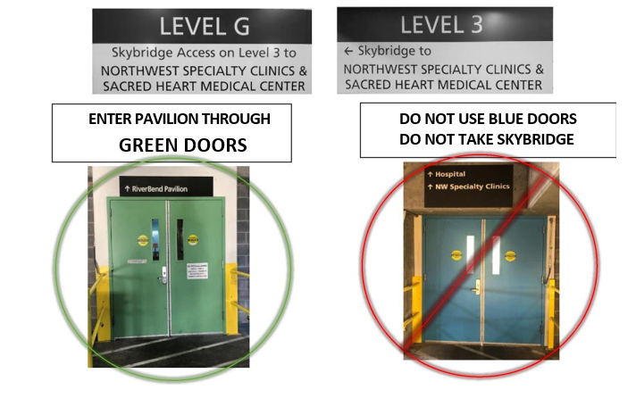

When inside the Pavilion building, take the elevator or stairs to the 2nd Floor.
Call for additional directions 541-222-6200

