Test | Test Codes | Swab / Transport Device | Stability and Transport Conditions | Specimen Source / Replaces
The Procedure Catalog is your one source of truth. It has all the information for all lab testing offered. Simply type procedure in the search bar header, hit run. Tests are selectable by name and LAB test code. 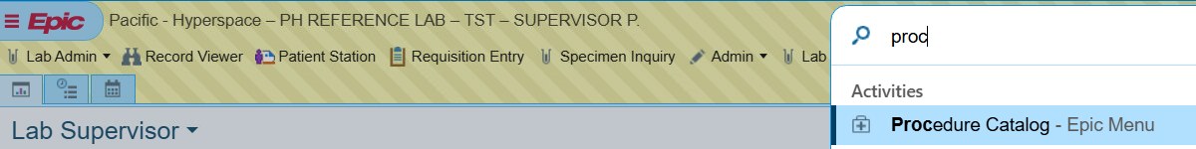

Chlamydia trachomatis/Neisseria gonorrhoeae (CT/NG) | LAB8054 (urine and female genital swab) | 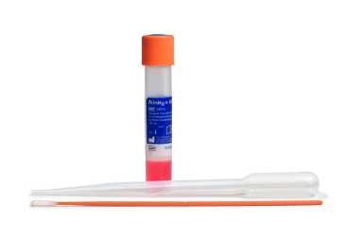 | Minimum stability is 14 days at Room Temperature (RT). | Transport Device: Alinity M multi-Collect.  Source: Validated for the following sources: Vaginal, endocervical and male and female urine.  Use orange handled swab or urine (FILL URINE TO MIDDLE OF WINDOW LINE).  Replaces Aptima Swab. *  Abbott Alinity M multi-Collect reference number: 09N19-015  Order through Infor (each box contains 500 swabs)
CT/NG PCR Throat | LAB8085 (throat) | 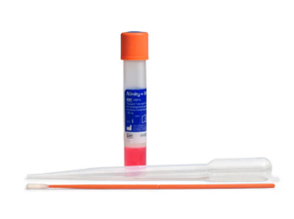 | Minimum stability is 14 days at Room Temperature (RT). | Transport Device: Alinity M multi-Collect  Source: Throat  Use orange handled swab or urine (FILL URINE TO MIDDLE OF WINDOW LINE).  Replaces Aptima Swab. *  Abbott Alinity M multi-Collect reference number: 09N19-015  Order through Infor (each box contains 500 swabs)
Test | Test Codes | Swab / Transport Device | Stability and Transport Conditions | Specimen Source / Replaces
CT/NG Rectal | LAB8079 (Rectal) | 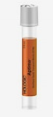 | Quest Test.  Stable 30 days at Room Temp. | Transport Device: Aptima  Source: Rectal  Order supplies through Quest
4-in-1 Sexually Transmitted Infection. Chlamydia trachomatis, Neisseria gonorrhoeae, Trichomonas vaginalis, Mycoplasma genitalium | LAB11040 |  | Minimum stability is 14 days at Room Temp. | Transport Device: Alinity M multi-Collect.  Source: vaginal, endocervical and male and female urine.  Use orange handled swab or urine (FILL URINE TO MIDDLE OF WINDOW LINE).  Replaces Aptima Swab. *  Abbott Alinity M multi-Collect reference number: 09N19-015  Order through Infor (each box contains 500 swabs)
Bacterial Vaginosis (Gardnerella, Trichomonas, Yeast)  Sureswab Advanced BV/CT/NG | LAB8540  LAB11036 | 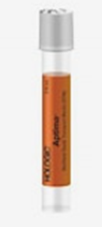 | Quest  Stable 30 days at Room Temp. | Transport Device: Aptima  Source: Vaginal
Test | Test Codes | Swab / Transport Device | Stability and Transport Conditions | Specimen Source / Replaces
Group B Streptococcus detection (prenatal) with susceptibilities | LAB8631 | 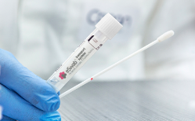 | 24 hrs. at RT. Swabs received 24 hours to 6 days after collection will be run with a disclaimer. | Transport Device: eSwab  Source: Vaginal/Rectal  Mfg. part number 480C  Order through Medline Punchout
Bacterial Cultures performed at PeaceHealth Reference Lab
Aerobic culture, | LAB8059 |  | eSwab: Stable 48 hours at RT.  Aspirate abscess material and tissue may be placed in the transport medium. Do not overfill. | Transport Device: eSwab  Source: Various specimen sources.  Mfg. part number 480C  Order through Medline Punchout
aerobic and anaerobic culture. | LAB8058
Staphylococcus aureus culture | LAB2882
Other tests still going to Quest
B. pertussis & B. parapertussis PCR | LAB923 | 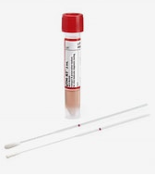 | RT for up to 48 h. | Transport Device: VCM, UTM or M4  Source: Nasopharyngeal aspirate or nasopharyngeal swab
Varicella Zoster Virus culture, Rapid Method | LAB8736 | VCM or FDA Approved VTM | Refrigerated 72h. | Transport Device: Viral transport medium  Source: Vesicle/lesion, throat swab or biopsy
Varicella-zoster Virus PCR | LAB1372 | Whole blood collected in EDTA  Viral transport medium for lesions | RT 48h. | Transport Device: EDTA whole blood or Viral Transport Medium  Source: Whole blood, Vesicle/lesion
HPV DNA (16,18, Other High risk), PCR, vaginal self-collect | LAB11384 | ThinPrep vial collected using Copan Floq swab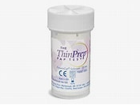 | RT 30 d. | Transport Device: ThinPrep vial  Source: Vaginal Self-collect
Fungal Culture (not skin, hair or nails) | LAB240 | Multiple types - see Procedure Catalog | RT 48 h. | Transport Device: See Procedure Catalog  Source: See Procedure Catalog
Fungal Culture (skin, hair, nails) | LAB1294 | Multiple types - see procedure catalog | RT 48h. | Transport Device: See Procedure Catalog  Source: See Procedure Catalog
Herpes Simplex Virus (HSV-1/HSV-2) PCR | LAB6615 | Multiple types - see procedure catalog | RT 48h. | Transport Device: See Procedure Catalog  Source: See Procedure Catalog
Culture, Genital | LAB8593 | Red Cap Amies liquid transport swab, blue cap Amies gel transport swab or eSwab.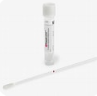 | RT 48. | Transport Device: Amies gel or liquid transport swab (includes eSwab)  Source: Vaginal, endocervical, urethral, prostatic secretions
Ear culture | LAB2501 | Outer ear use transport or eSwab. Inner ear use sterile needle and syringe. | eSwab: 48h. RT  Other swab: 24 h. RT | Transport Device: eSwab or syringe with needle removed and sterile cap in place (for inner ear specimen).  Source: Outer or inner ear
Eye culture and gram stain | LAB2533 |  | If Neisseria gonorrheae suspected: 24 h. RT on eSwab | Transport Device: eSwab  Source: Eye

Coming Soon July - August 2026
Women’s Health Vaginosis / Vaginitis  Gardnerella, Trichomonas and Yeast | LAB11036 (it will be the same code as the Quest test) | 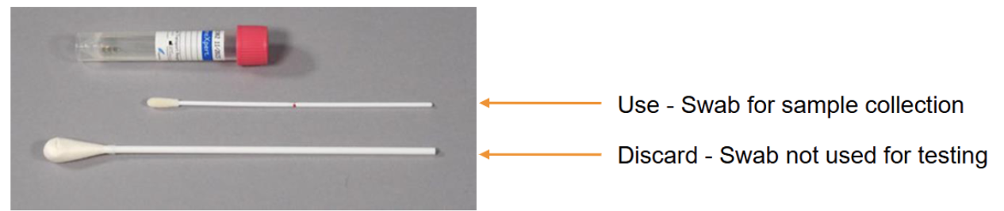 | Cepheid Xpert Swab Collection Kit | SWAB/G-50 US

